- \Operation\Monitoring dust flap\Monitoring dust flap
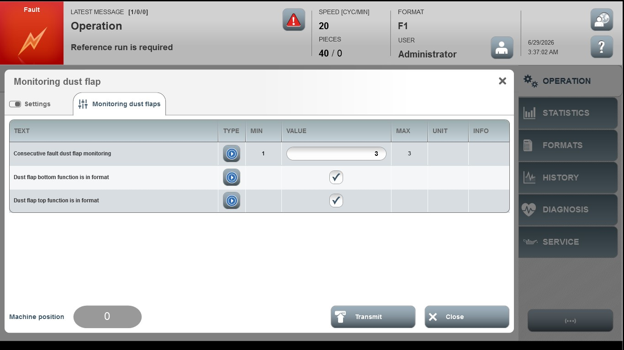
Acceptance criterion | Limits | Pass / Fail: Dev-No. | Date | Initials
Screen matches screenshot | N / A
Consecutive fault dust flap monitoring | 1…3

